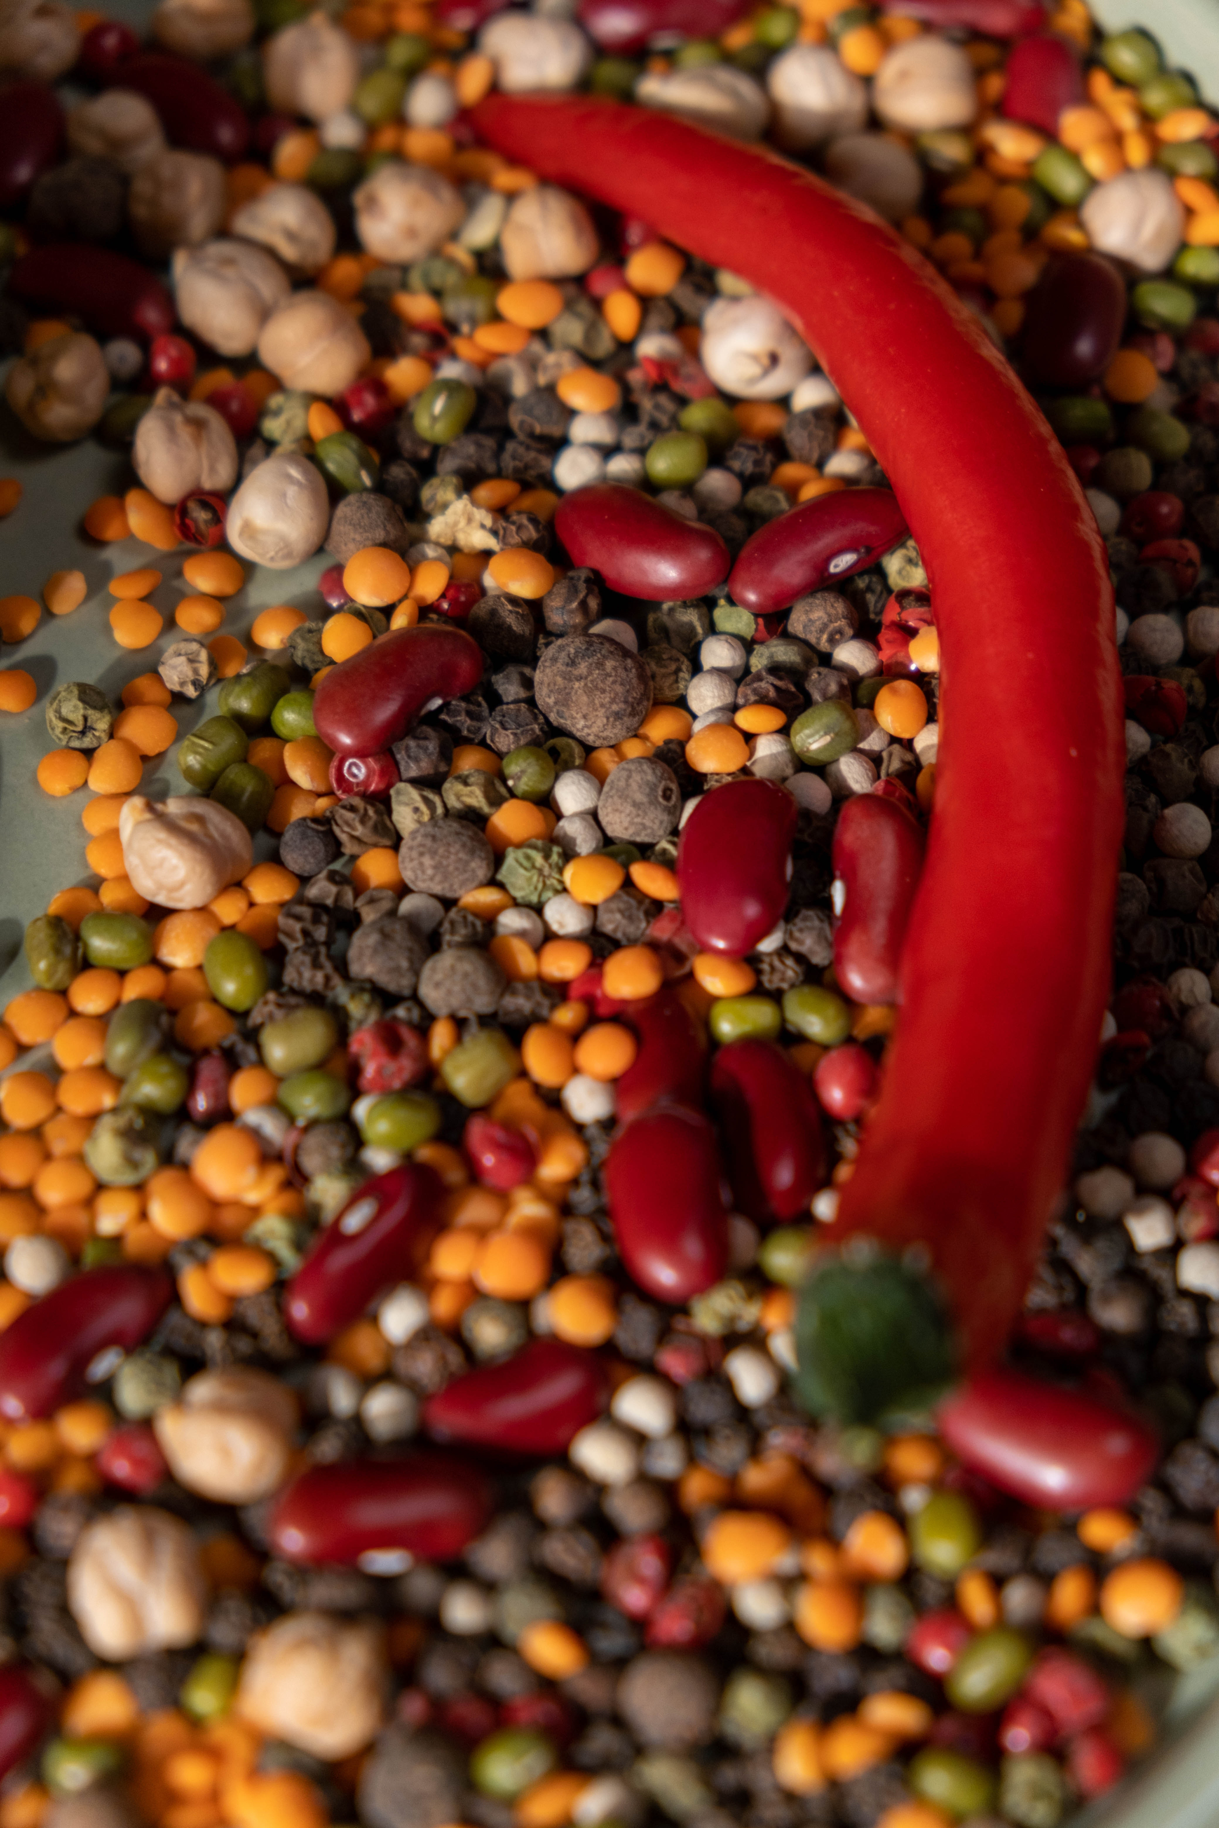



Pathfinder

**Decision support system for assessment and management of sustainability of legume agri-food chains**

User Manual

# Introduction

The **PathFinder** (<http://pathfinder.ijs.si/>)is a Decision Support System (DSS) for the assessment and management of sustainability of legume agri-food value chains and has been developed within the Horizon 2020 TRUE project (https://www.true-project.eu/). It assesses the sustainability according to the ‘three pillars of sustainability’: **environmental**, **economic,** and **social**, as well as their intersections: **equitability**, **bearability** and **viability**. The system provides partial sustainability assessments for individual links in the agri-food chain (production, processing, transport and distribution, market and retailers, and consumers) and individual sustainability pillars, as well as an overall sustainability assessment and management of the whole chain. It enables the users to modify the input variables, so as to ascertain optimal combination of input variables of the individual links in the agri-food chain that lead to satisfactory partial or overall sustainability. It also offers suggestions for changes in certain areas of the agri-food chain to improve its overall or partial sustainability.

The DSS is developed primarily for policy makers and researchers, who are responsible for development of sustainability strategies, polices and regulations towards reaching the Sustainable Development Goals 2030. The PathFinder could be used also as an education tool that allows students to learn about those factors, and their functional relationships, which determine the sustainability of agri-food value chains.

To start using the PathFinder, the users must first register and create their own account. This enables them a personalised experience of the use of the DSS, as well as privacy security regarding the input data and the results obtained. By registering, the user can revisit the input data and the obtained results and work on them continuously for a longer period, without having to input the data repeatedly.

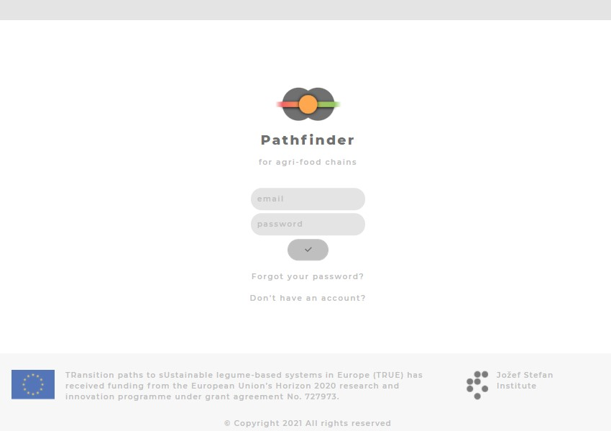

# Starting the PathFinder

When the user starts the PathFinder, a window opens where a choice should be made about whether to create a new assessment, open a previously created assessment or consult the user manual for instructions about the use of the DSS. If the user has already used the system before, they can revisit the data and results of their previous assessments.

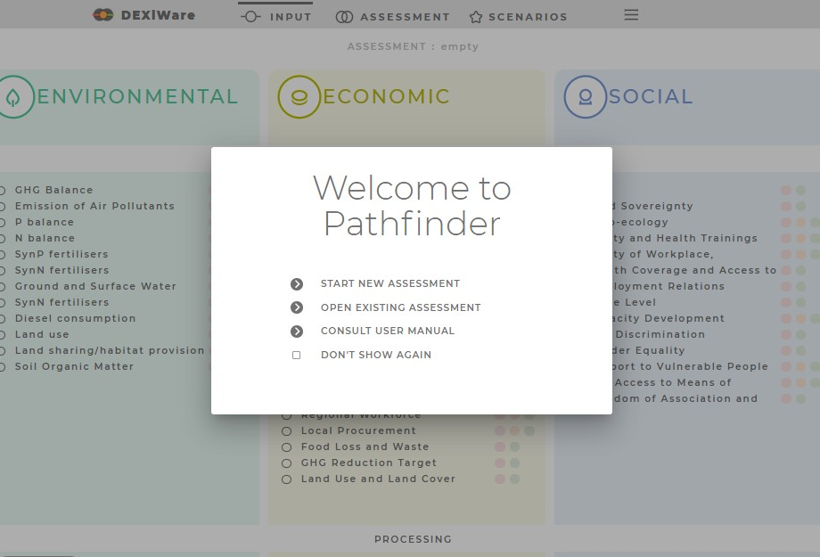

# Input data

The next step when using the PathFinder is to insert data about the links in the agri-food chain for the three pillars of sustainability: **environmental**, **social,** and **economic**. They represent three categories of input data, which are represented in different sections with different colours. Each of these three categories of input data are further divided into subcategories, representing the links in the agri-food chain (from production to consumers). By clicking on one of the categories (pillars), the user will be guided through the list of input data to insert their values and populate the DSS with the required data for assessment of the environmental, economic, and social sustainability pillars in the agri-food chain.

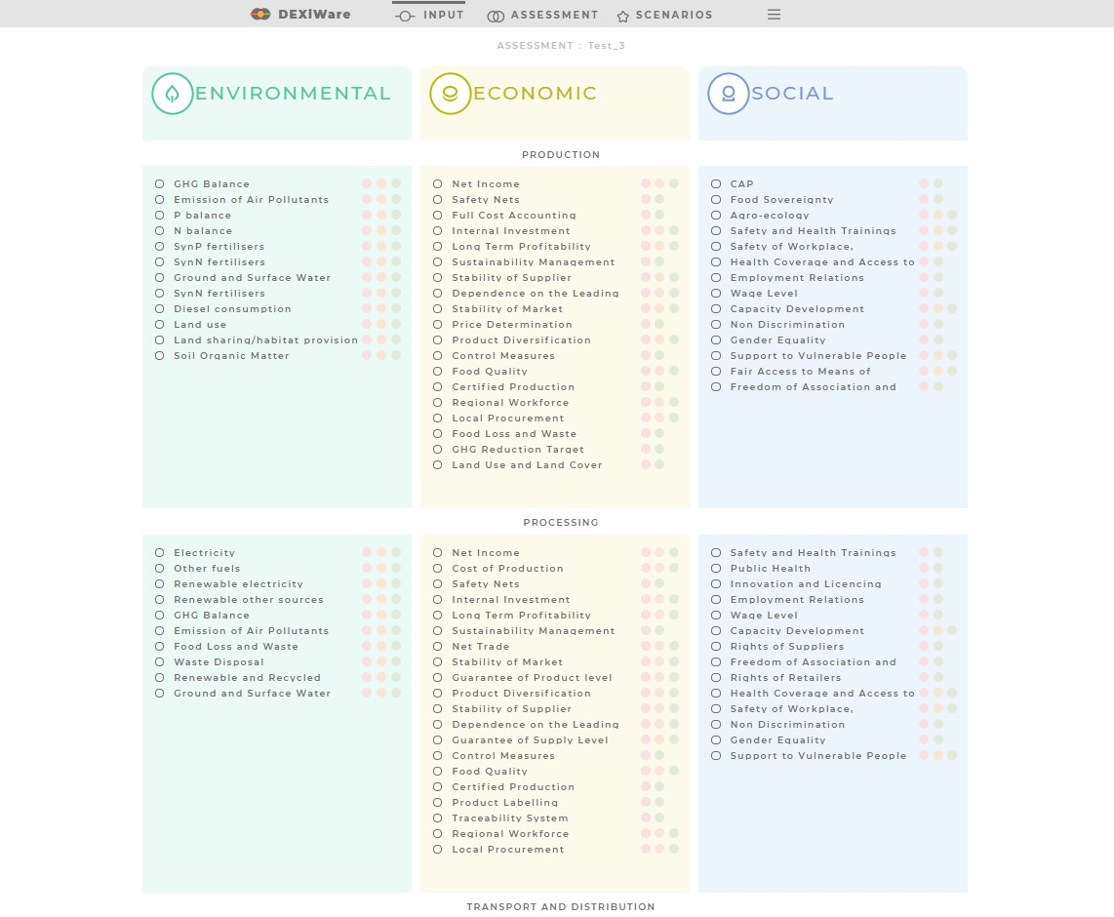

# Inserting data

The input data takes the form of qualitative indicators for which the user chooses one of its qualitative values (*e.g.,* low, medium, high). Both the indicator and its values are provided with short and understandable descriptions that help the user to choose the right input values. By clicking on one of the input data categories (pillars), a page will open, where the first indicator from the list of input data for the chosen category (pillar) will be shown.

**1**

* This part represents the subcategories of input data (*e.g.,* Production) within the selected category (*e.g.,* Environmental). The dots on the horizontal line next to the subcategory title navigate the user through the list of indicators, showing how many indicators have already been inserted and for how many indicators are there left. A dot coloured in grey represents an indicator for which a value has been inserted. A white dot represents an indicator, for which a value has not been inserted yet. If the user scrolls over a dot, the name of the indicator is shown. The user can “jump” to an indicator by clicking on a dot representing the indicator.

**2**

* A description of the indicator.

**3**

* This is the part where the user chooses one among the proposed and described qualitative values for the chosen indicator that belongs to the production system that is being evaluated.

**4**

* Navigation buttons to the next or previous indicator.

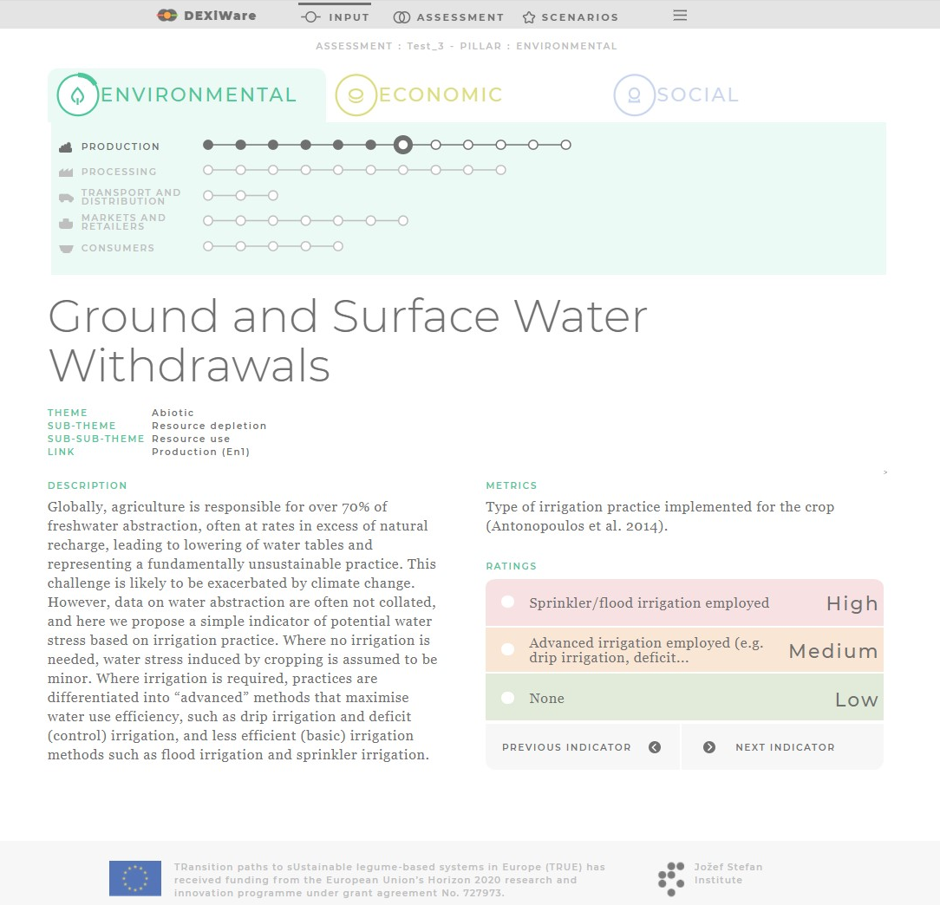

**3**

**2**

**1**

**4**

After coming to an end inserting data for a category (pillar), a window opens informing the user whether all the required data were entered (note that if the user does not have all required data available, he/she can leave the indicator empty). If all data were entered, the system informs you about the transition to the next pillar. However, the user is advised to enter as much data as possible. The tool assesses each pillar of sustainability for each link in the agri-food chain separately, so data for only one of these aspects/categories can be inserted to get an assessment for that aspect/category only.

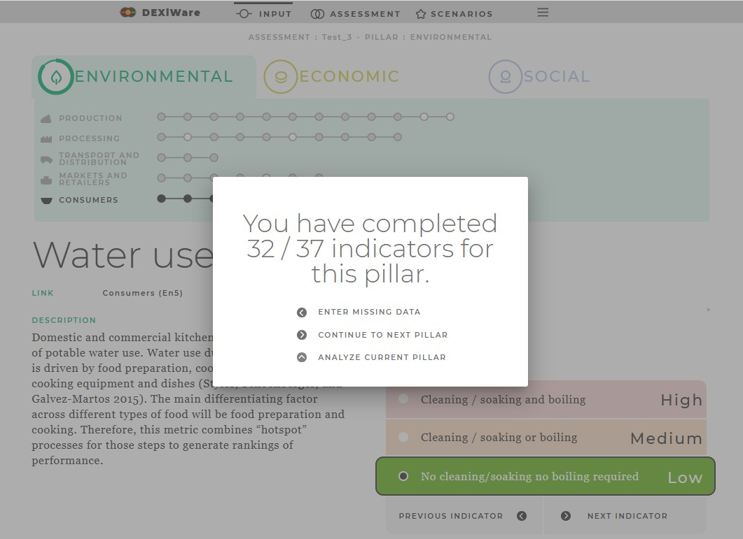

By clicking on ***INPUT*** in the upper menu bar, the page with the list of all indicators for all categories of input data will be shown, where the user can check which indicators have already been inserted (coloured dot next to the indicator) and which are still empty. In this way, the user can have an additional overview of the input data before running the analyses.

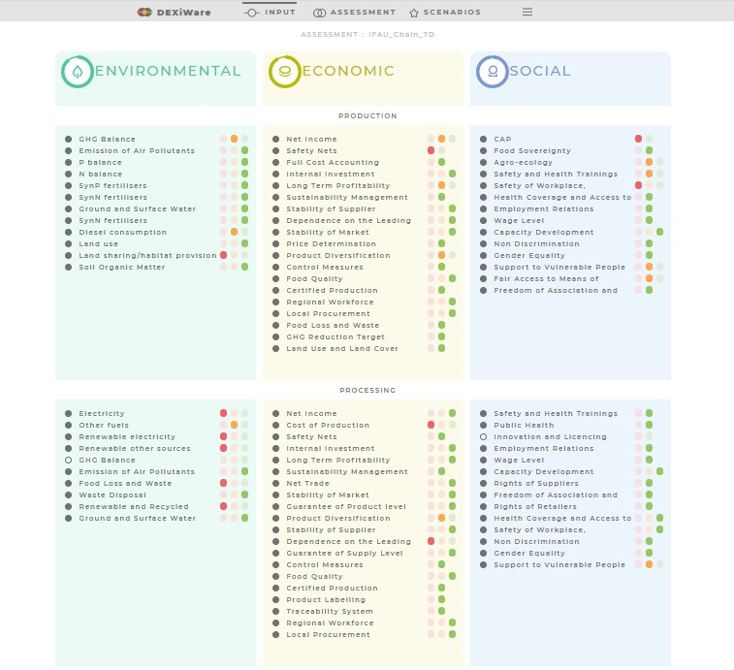

# Assessment

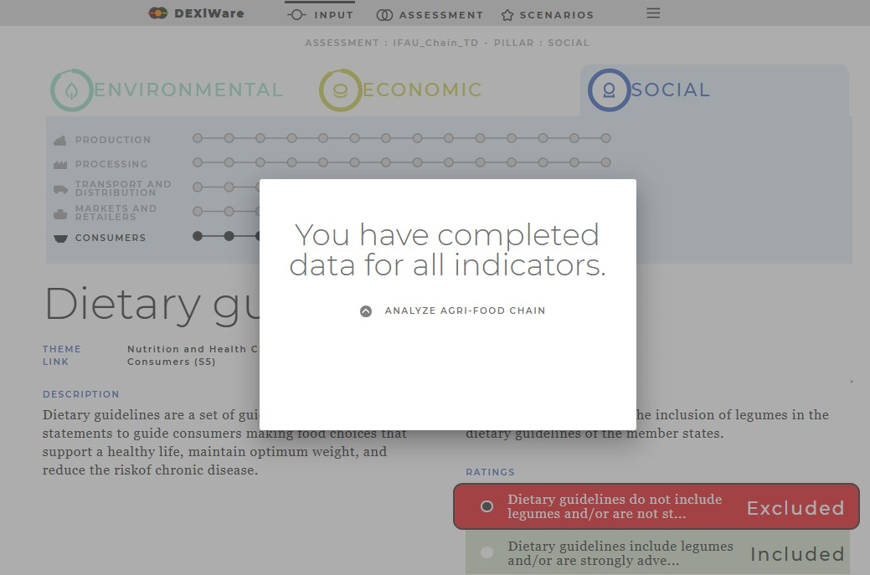 Once the values of the indicators in all three pillars are entered, a window opens informing the user that they have completed the entries and can proceed with the analysis to obtain a sustainability assessment of the entire agri-food chain.

The results of the sustainability assessment of the chosen agri-food chain are visually presented:

**1**

* The colours of the large circles and their intersections represent the results of the sustainability assessment. The overall sustainability level of the entire agri-food chain is shown in the centre of the rose where all three sustainability pillars overlap. The three circles represent the three sustainability pillars (environmental, economic, and social) and their intersections: bearability, viability and equitability, of the agri-food chain. When data for a certain pillar are completely missing (not inserted), the circle representing that pillar is coloured in grey, which would mean that there is no assessment for that pillar.

**2**

* This part shows the results of the assessments for the individual links in the agri-food chain for each sustainability pillar (environmental, economic, and social). In case that some input data are missing, two possible outcomes/assessments can be equally probable. In that case, the circle can be one of two colours, representing the combination of possible outcomes.

This button (***BOTTOM UP SCENARIO***) enables the user to explore in what way the changes at the lower level (input data or link level) influence the sustainability on higher levels (link in the agri-food chain, or the entire chain). In this way, the user can perform what-if analysis and see the differences the changed input makes to the final outcome, compared to the original assessment.

**3**

**4**

This button (***TOP DOWN SCENARIO***) allows the user to choose a desired partial or overall level of sustainability. The system then searches for options that would lead to the desired sustainability level and provides the user with scenarios in which the desired sustainability level is achieved. This would give the user advice in which parts of the agri-food chain changes should be made so that the desired sustainability is achieved.

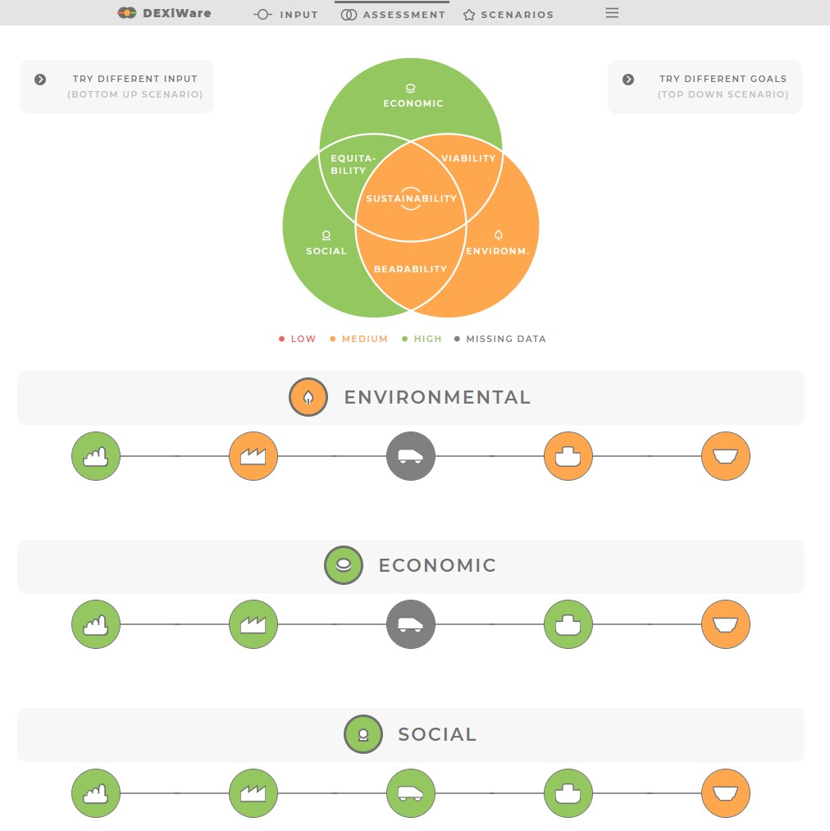

**2**

**4**

**1**

**3**

# Saving the assessment

By clicking on ***SELECT ASSESSMENT*** in the navigation bar (‘hamburger button’, three short stacked parallel horizontal lines) in the upper right corner, the user can name and save the current assessment. In addition, the user can also open, rename or delete already saved assessments.

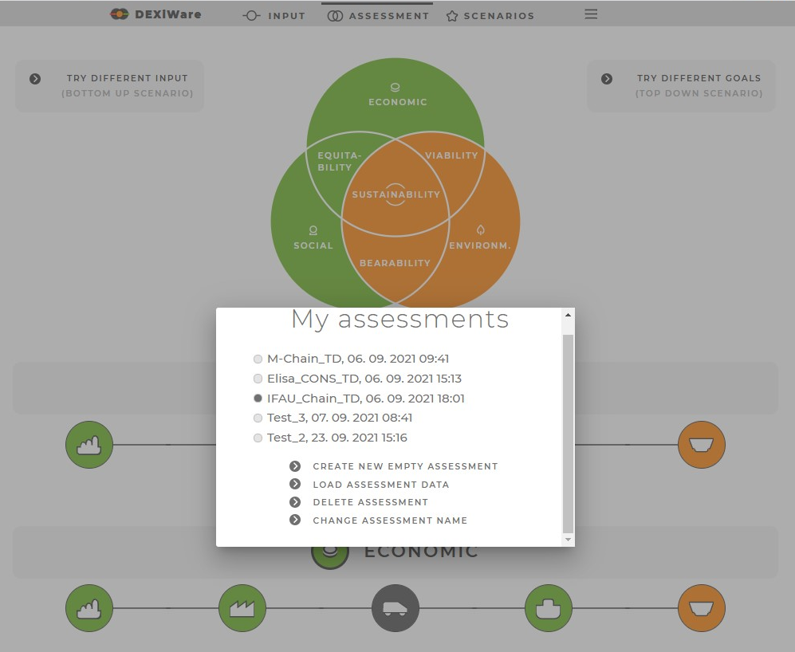

# Bottom-up scenario

By clicking on the ***TRY DIFFERENT INPUT*** button, the users can explore what impact would the changes of the input data have on the sustainability performance of the agri-food system being assessed. If the users are not satisfied with the assessed level of sustainability, this option will help them to find which parts of the agri-food chain should be improved to enhance the overall sustainability of the agri-food chain. The users must change the values of the input data (indicators) and observe how these changes affect the sustainability performance at the different levels of the assessed agri-food system.

**1**

* The circles on the upper left side represent the assessed overall sustainability and its pillars and their intersections for the chosen scenario.

**2**

* To see what impact changes of the input data would have on the sustainability performance of the agri-food system being assessed, the user first changes the value of the indicator(s) or sets the desired value for the selected link or pillar by clicking on the corresponding circle. Note that it is not possible to change the values at all levels at the same time.

**3**

* After changing the input values of the indicators, links, or pillars, click on ***EVALUATE CHANGES*** button and the DSS will make a new assessment of all sustainability aspects of the selected agri-food system.

**4**

* A new sustainability assessment of all links and pillars of the selected agri-food system is provided.

**5**

* Clears all changes made to the values of the indicators and the links and shows the original values of the input data. New changes of the input data or links goals can be made.

**6**

Saves the current assessment scenario for further use and inspection. The user can choose a name for the scenario for easier navigation through them.

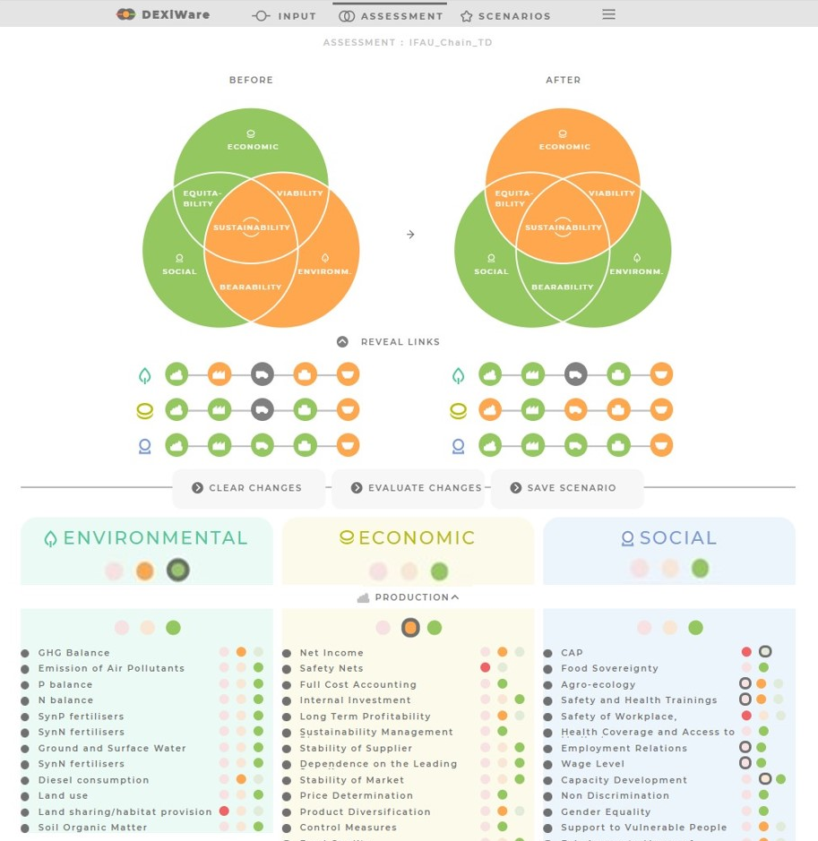

**6**

**5**

**3**

**2**

**4**

**1**

# Top-down scenario

By clicking on the ***TRY DIFFERENT GOALS*** button, the user can explore the pathways that will lead them to the desired sustainability level of the agri-food chain and will provide advises about the necessary changes of the current situation that would lead to the desired sustainability performance of the entire chain or its parts. Once the user sets the goals about the desired level of the sustainability performance, they must change the assessed sustainability levels to the desired levels. By clicking on the triangle button next to the sustainability pillar or pillars’ intersections, the user increases or decreases the sustainability levels according to their goals. The DSS then provides pathways (scenarios) that lead the user to the desired sustainability levels. The scenarios give detailed information of the needed changes that will provide the desired sustainability levels. This would give the user advice in which parts of the agri-food chain changes should be made so that the desired sustainability is achieved. The user can save the optimal scenario for further inspection.

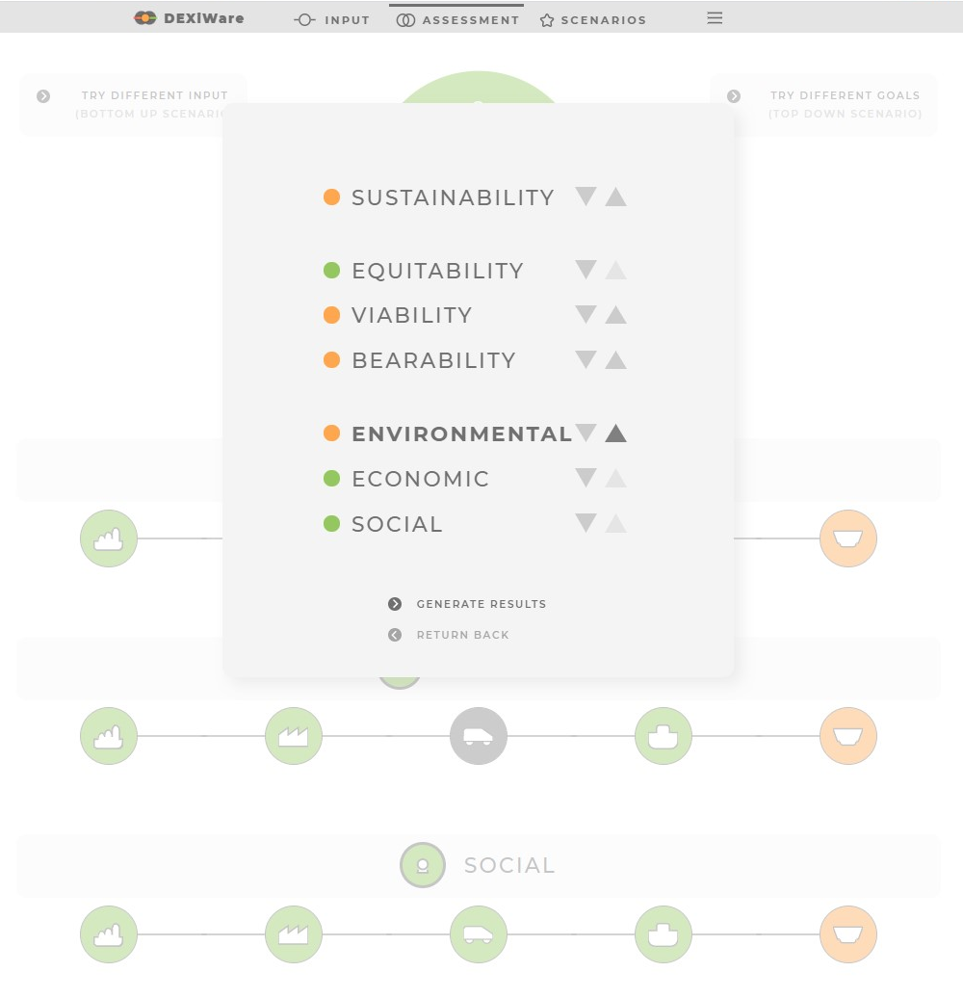

**1**

Visualization of the results of the currently assessed agri-food chain.

**2**

* Sustainability levels of the links under the changes proposed by Pathfinder.
* Sustainability levels of the agri-food chain, its pillars and their intersections under the changes proposed by Pathfinder.

**3**

**4**

A list of changes proposed by PathFinder that should be made in the agri-food chain in order to achieve the desired sustainability level.

**5**

Save the proposed scenario for further use and inspection. The user can choose a name for the scenario for easier navigation through them.

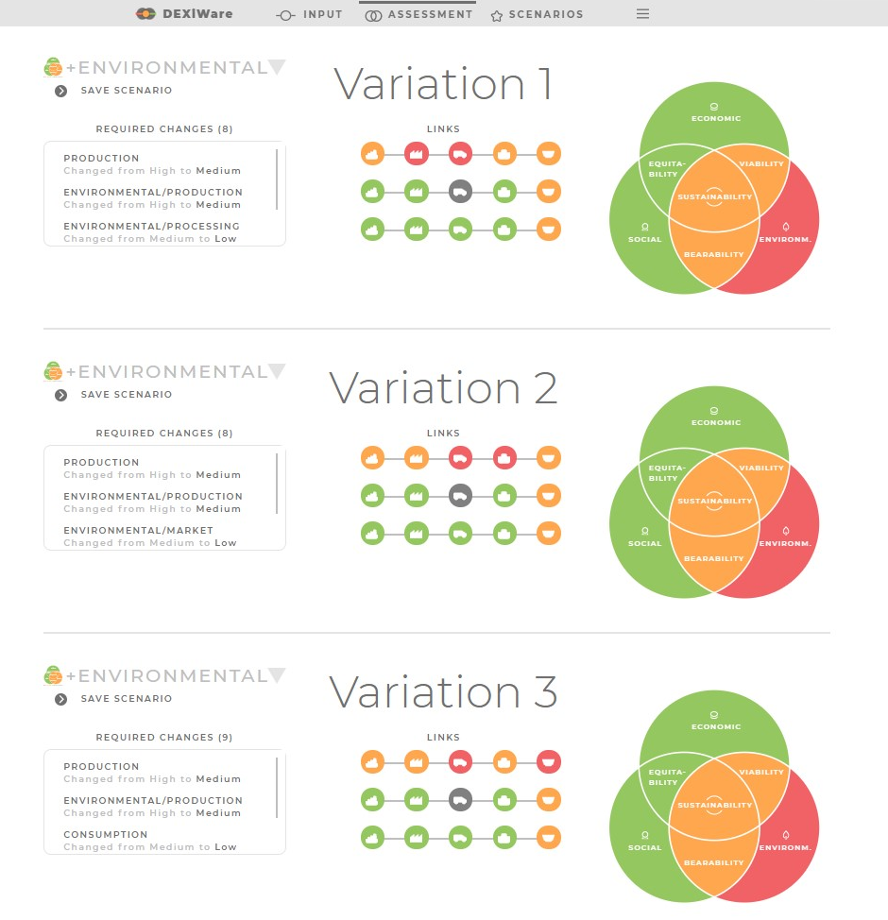

**1**

**3**

**4**

**2**

**5**

# Review of saved scenarios

The saved scenarios for both bottom-up and top-down analysis are shown by clicking ***SCENARIOS*** in the upper menu bar. Since the user has the option to create and save several scenarios in the bottom-up analysis and to select and save several variations in the top-down analysis, this option provides a transparent way to review all saved scenarios/variation.

**1**

Click on ***BOTTOM-UP SCENARIOS*** or ***TOP-DOWN SCENARIOS*** to visualize the scenarios.

**2**

* This button allows the user to see the saved scenarios for the bottom-up analyses. The saved scenarios include the before and after results of the analyses, names of the scenarios/assessments and list of all input changes that the user made.
* This button allows the user to see the saved scenarios for the top-down analyses. The saved scenarios include the before and after results of the assessment of the whole chain and its links and a list of all needed changes that should be made in the agri food chain.

**3**

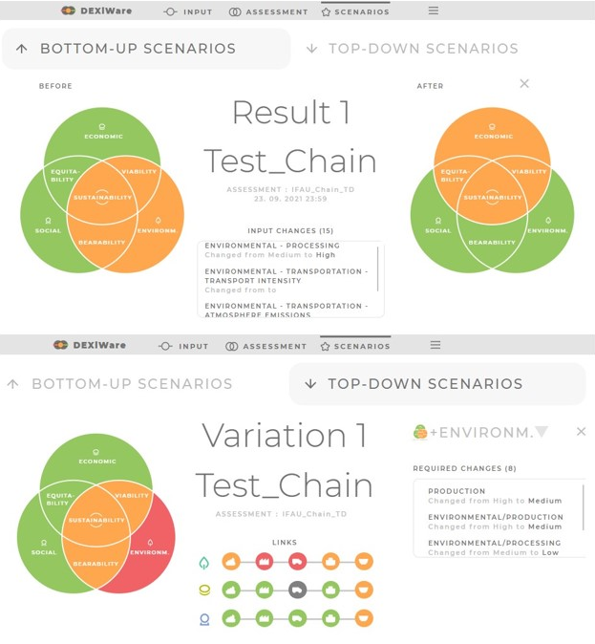

**1**

**2**

# Exporting the results

The PathFinder enables an export of the report of the analysis in a PDF file. The report contains the input data, the assessment results, and the saved scenarios of what-if and top-down analysis. The PDF document is the only export from the Pathfinder, which can be used for exploitation and communication purposes. The export option is in the navigation bar (hamburger button) in the upper right corner.

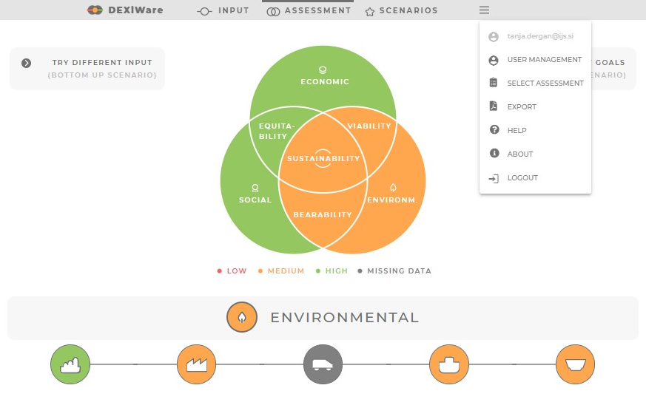

# User management

The user management functionality of PathFinder, found in the upper right corner, enables all the registered users to invite collaborators to help gather all the needed data and give them different permissions about the input of data. The permissions can be fine-tuned for each data input section (indicator, pillar, link). Due to the complexity of the agri-food chain and large amount of required input data, the user management will facilitate the involvement of data providers for different links or the agri-food chain in obtaining high quality data.

**1**

By clicking on one of the three pillars, the user selects the pillar to which he invites collaborators to help him collect the data they need.

Invite collaborators to use the system, by entering their name and email. Collaborators get an invitation on their email, which allows them to work on the assigned example.

**2**

**3**

List of invited collaborators added to the system. In addition to the collaborators name, it also shows the assigned permissions and how much of it has been completed.

**4**

* List of indicators in the selected pillar, for each link in the agri-food chain. This allows the user to have a better overview of the input data needed and assignments of different collaborators.

**5**

* By clicking on the sign ( ), the user assigns the collaborator permission to input data or modify the value of the indicator. The collaborator can input data or modify only the indicators assigned to them by the user.

**6**

* By clicking on the sign ( ), the user assigns a read-only permission to a collaborator. The collaborator now has no permission to input data and is therefore participating only as an observer.

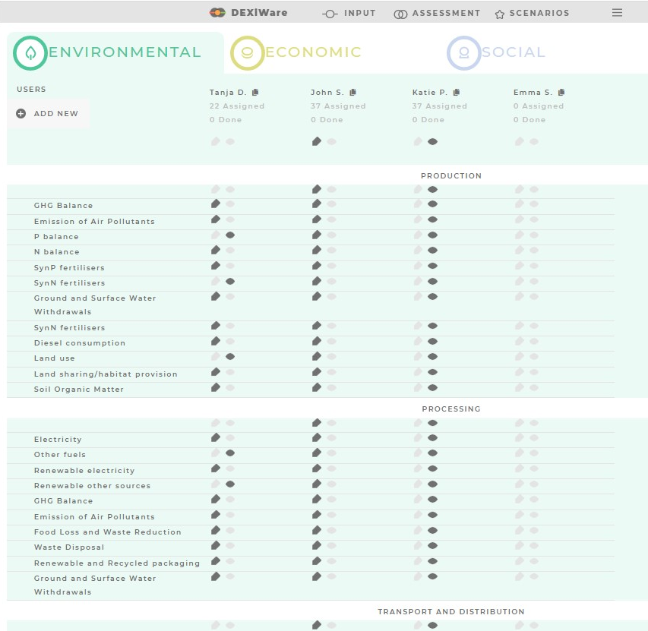

**6**

**5**

**4**

**3**

**2**

**1**

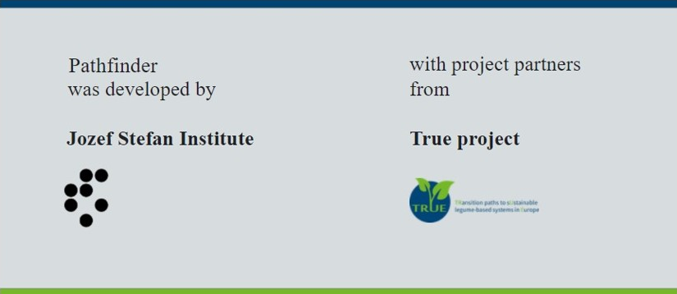

Latest version of the PathFinder: 28 September 2021

For further information about the PathFinder please contact us:

dexiware@ijs.si



TRUE project has received funding from the European Union’s Horizon 2020 research and innovation programme under GA No. 727973